The dataset consists of tweets collected using Tweepy from February 25th to March 31st 2018. The data was collected by Siyan Chen, Bhavika Jalli, Cixing Li and Vidya Mansur from the University of Michigan.

Each tweet is in the form of a dictionary with the fields

* screen name,
* re-tweet_count,
* replied_to,
* text
* Location
* Hashtags_in_the_tweet
* created _at
* Mentions_in_the-tweet
* Name and
* User_ID

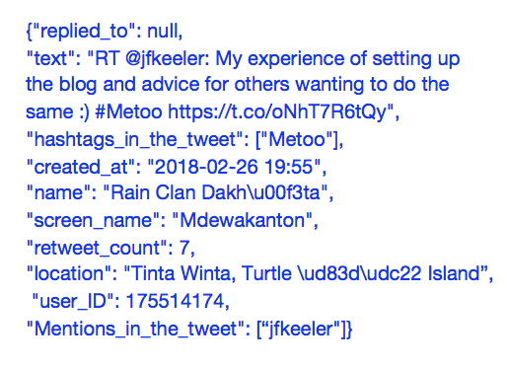

Each tweet dictionary is on a new line.